📘 Master Sales Portfolio
Sector Integration – Pharmacy & Pharmaceutical Operations
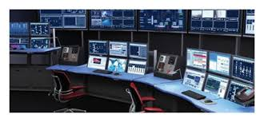
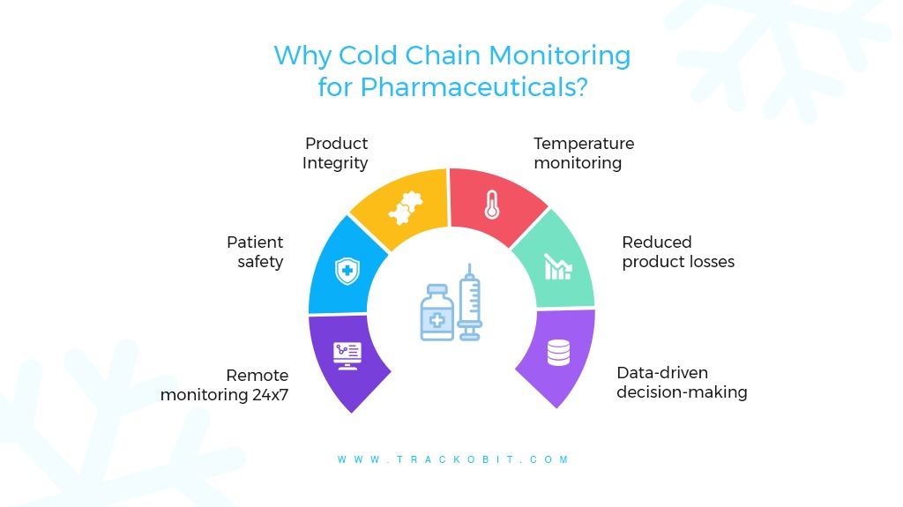
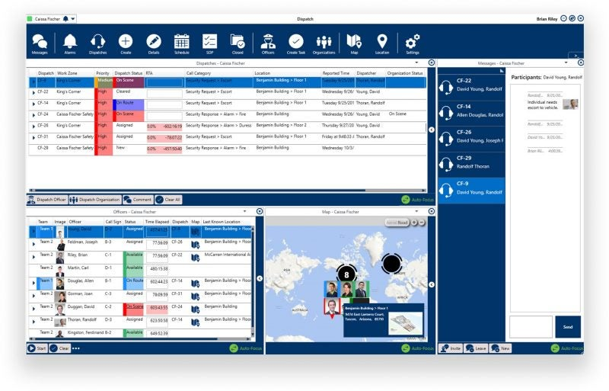
4

Portfolio Section Positioning
Utility-Grade Automation for Regulated & Cold-Chain-Critical Industries
The Pharmacy & Pharmaceutical sector is positioned after Medical Facilities and before Mega Buildings / Data Centers in the portfolio, reinforcing the message:
Hospitals → Pharmacies → National Supply Chain → Public Health Security
This sequencing strengthens your Vision 2030 alignment and justifies 7–15+ M SAR budgets naturally.

Sector Overview – Pharmacy & Pharmaceuticals
Why This Sector Matters
Pharmacies, pharmaceutical manufacturers, and distribution hubs are mission-critical national assets.
Failure does not mean inconvenience — it means:
- Product recalls
- Regulatory violations
- National healthcare disruption
Most existing systems are BMS-level and not designed for regulated, audit-driven operations.

Our Positioning for This Sector
Mohammed Al-Ojaimi Energy Services – Automation Department delivers utility-grade operations and compliance platforms for pharmaceutical environments, engineered with the same rigor used for power utilities and control centers.
Medicines are critical assets — their infrastructure must be operated like critical infrastructure.

Target Clients (Saudi Market)
This offering targets high-budget, centralized operations, not retail outlets:
- National pharmacy chains (central warehouses)
- Pharmaceutical manufacturing plants
- Vaccine & cold-chain logistics hubs
- Government healthcare supply facilities
- Large regional distribution centers
Typical Engagement Size: 7 – 15+ Million SAR

Executive Problem Statement
Pharmacy executives face:
- Temperature excursions with delayed detection
- Manual compliance and audit reporting
- Fragmented refrigeration, HVAC, power systems
- Alarm floods with no escalation logic
- High energy cost for cold storage
- Weak traceability during SFDA audits
These translate into direct financial loss and regulatory exposure.

Integrated Solution Architecture
A centralized Pharmaceutical Operations & Compliance Platform, built on
COPA-DATA zenon, integrating:
- Cold rooms & refrigeration systems
- HVAC & controlled environments
- Power, UPS, generators
- Temperature & humidity IIoT sensors
- Energy meters & sustainability KPIs
- Warehouse automation systems (monitoring layer)
- Alarm & event management
- Historian & automated compliance reporting
One platform. One audit-ready source of truth.

Key Value Use Cases (Portfolio Level)
🔹 Cold-Chain Integrity Management
- Continuous monitoring
- Automated deviation detection
- Escalation & acknowledgment tracking
- Incident replay & root-cause analysis
🔹 Compliance & Audit Readiness (SFDA / GxP-Aligned)
- Automated, time-stamped logs
- Tamper-resistant historical data
- One-click audit reports
- Zero manual spreadsheets
🔹 Energy Optimization for Cold Storage
- Load profiling of refrigeration systems
- Peak demand reduction
- Cost-per-product storage analytics
- ESG & sustainability reporting
🔹 Centralized Operations Command
- Multi-warehouse visibility
- Executive dashboards
- National-scale oversight
- Faster decision-making during incidents

Executive Business Value
Area | Typical Impact
Temperature Excursions | −70–90%
Compliance Effort | −60–80%
Product Loss Risk | Near-zero
Energy Cost | −10–18%
Audit Readiness | Continuous
The ROI is driven by avoided recalls, rejected batches, and regulatory penalties — not IT savings.

Why Al-Ojaimi (Portfolio Message)
Across utilities, hospitals, factories, and now pharmacies, we consistently deliver:
- Utility-grade engineering discipline
- Vendor-agnostic, scalable platforms
- Strong power & redundancy expertise
- Cyber-secure OT architectures
- Single accountable automation partner
Few integrators can credibly operate in all four domains.

Portfolio Placement Summary (Final Slide)
Industries We Serve with Utility-Grade Automation
✔ Power & Utilities
✔ Industrial & Process Factories
✔ Medical Facilities & Medical Cities
✔ Pharmacy & Pharmaceutical Operations
✔ Mega Buildings & Data Centers

